Module 1: Risk and Insurance

Lesson 4: The Value Exchange in the Insurance Transaction

Learning Objectives
After studying this lesson, you will be able to:
- Explain the role of actuaries (chuyên gia định phí) in setting premium rates.
- Define a premium rate, and calculate the annual premium amount for a given life insurance policy.
- Explain how actuaries account for the cost of benefits (chi phí quyền lợi), investment earnings (thu nhập đầu tư) (, and expenses (chi phí hoạt động) in developing premium rates.
- Explain how insurers use mortality tables (bảng tử vong) for pricing products, and describe the effect that mortality rates have on the cost of benefits and the premium rate for a block of policies (nhóm hợp đồng).
- Describe the effect of compound interest on investment earnings, and calculate the amount of interest earned on a given sum of money.
- Describe how pricing factors (yếu tố định giá) affect profit levels.

Actuaries and Premium Rates
Explain the role of actuaries in setting premium rates.
Define a premium rate, and calculate the annual premium amount for a given life insurance policy.

What do you think?
Simone’s $500,000 life insurance policy has an annual premium of $1,056. Although Simone is relieved to know her family would be financially okay if she should die prematurely, she has begun to question the cost of the policy. If she asks John how the insurer determined that $1,056 premium amount, which of the following do you think he might talk about with her? (Choose all that apply.)
- Investment earnings
- Cost of benefits
- Profit
- Operating expenses
Answer: All is correct
Explanation: All of these factors play a part in determining the premium for a life insurance policy, and we’ll look at each of these factors in this lesson.

The Value Exchange
Recall, that to have a valid contract, the parties must exchange consideration or something of value. In exchange for paying premiums, Simone transferred the risk of financial loss to Able Life and gained peace of mind that her family would be financially okay if she should die prematurely.

In exchange for accepting this risk from Simone, Able Life will receive premiums from Simone, which it needs to continue to operate as a business. That's the value exchange.

Actuaries

Actuaries specialize in calculating the financial impact of risk and uncertainty. They rely on the mathematics of insurance to determine how much insurers should charge customers so that the company can
- Pay all future benefits
- Cover operating expenses
- Make a reasonable profit

The Actuary
See as this actuary explains how he decided to become an actuary and the various roles actuaries play in a life insurance company.

Anthony Ferraro
Vice President and Actuary
New York Life:

When I first went into the field of becoming an actuary, I wasn't exactly sure what an actuary did and a friend of mine, he was a math major and he went into actuarial science. I was actually working as an accountant initially and we had conversation. He said "Yeah, I'm an actuary" and I said "Well, what exactly do you do?" He explained to me that actuaries look at risks within the company. We look at contingent events and I thought, "Wow, I'm an accountant right now and I'm counting all the beans that I can see, it might be kind of fun to count these beans in the future that I'll never see, or may not ever see."

I decided to look into it. When you start researching a profession, you unveil what it actually is and what it's about and the mystery gets taken away from it. Actuaries really play in a lot of different roles in the company.
They run the gamut from being in the business and looking at strategy to being very technical and looking at valuations and exactly how much reserve should we hold, to doing a little bit of both, which is what the pricing actuary tends to do. Gets involved very much in the business strategy and what markets are we going after. What needs do I have to, how do I price this so that it meets the market need?

Then there's some very technical details in the background to actually coming up with the profitability and the assumption setting. It's a nice balance and I've enjoyed doing that, having that balance throughout my career.

Premium Rates

Actuaries don’t set the exact premium amount that each policyowner pays. Instead, for each product, actuaries establish a premium rate per unit of insurance coverage. Actuaries express a premium rate as a "rate per thousand per year.
1 unit = $1,000 of life insurance coverage

We know that actuaries don’t just make up premium rates at random. But… premium rates have to be

Adequate: (đầy đủ) The company will have enough money to pay policy benefits.
Equitable: (công bằng) Each policyowner pays a premium that reflects the degree of risk he presents to the insurer

Developing Premium Rates

Learning Objective
Explain how actuaries account for the cost of benefits, investment earnings, and expenses in developing premium rates.
Explain how insurers use mortality tables for pricing products, and describe the effect that mortality rates have on the cost of benefits and the premium rate for a block of policies.

Pricing Factors
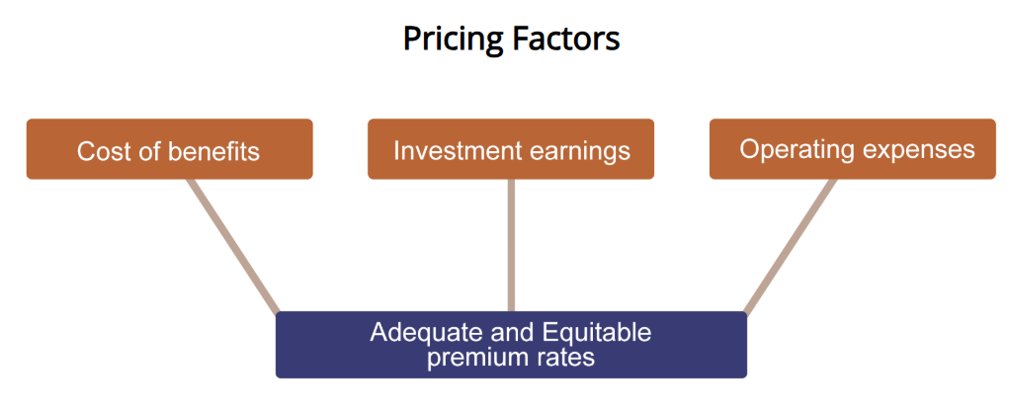

To develop adequate and equitable premium rates, actuaries take into account the following factors:

Life Insurance Benefits
The main benefit provided by a life insurance policy is the death benefit that is paid when an insured dies. Some life insurance policies also include a surrender benefit. If a life insurance policy contains a savings element, the policyowner may receive the accumulated value—the cash value—of the policy as a surrender benefit.

In addition, a life insurance policy or an annuity contract may include several other types of benefits that we will describe later in this course. Actuaries must determine the cost for all of the benefits provided by a policy.

Cost of Benefits
The cost of benefits equals all of the insurer’s potential benefit payments multiplied by the expected probability that each benefit will be payable.
Cost of benefits = (potential benefit #1 × probability of payment) + (potential benefit #2 × probability of payment) + …

Some products have only one benefit; other products may have many different benefits. Regardless of the number of benefits in a product, dealing in probabilities is where this stuff can get tricky for an insurer.

What do you think?
To determine the cost of benefits for life insurance products, actuaries must make statistical projections about (choose all that apply)
- How many insured people will die each year
- Exactly which insured people will die each year
- How many policyowners will lapse or surrender their policies
Answer:
- How many insured people will die each year
- How many policyowners will lapse or surrender their policies
Explanation: Actuaries don’t try to predict who will die each year…but they are interested in how many insured people will die each year, as well as how many will surrender their policies and how many policies will lapse for nonpayment of premiums. We’ll discuss lapses and surrenders more later.

Mortality Rates
To have the funds needed to pay life insurance claims as they come due, and to determine the cost of benefits for a life insurance product, actuaries must estimate the number of deaths that will occur each year.
3 of 15 insureds die. Mortality rate = 20 percent.
The mortality rate is the incidence of death, by age, among a given group of people. To price a life insurance product, an insurer must be able to predict the mortality rate for a given group of insureds.

Mortality Tables and Mortality Rates
Mortality tables (A chart that displays the number of people in a large group who are likely to die at certain ages.) display mortality rates for a given group of people at each age.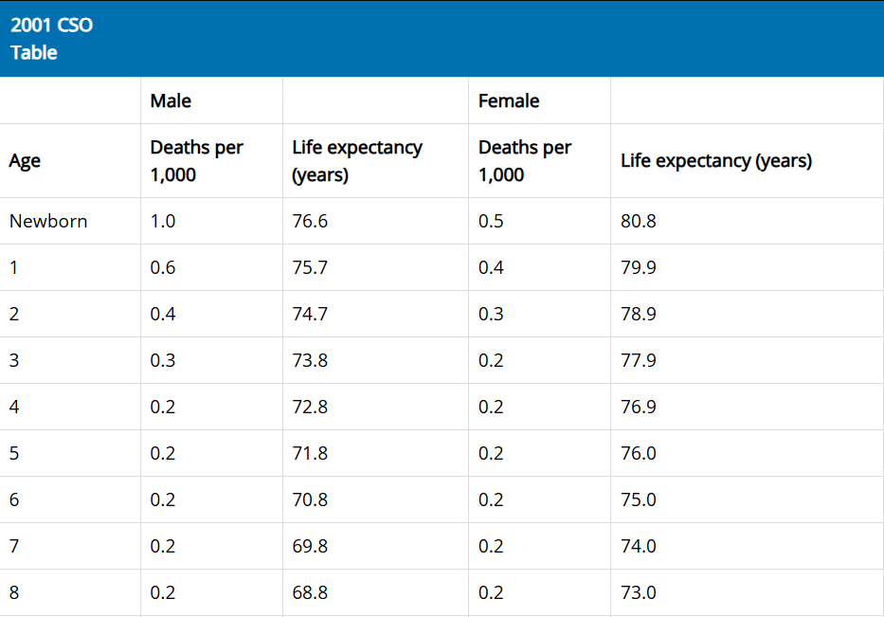
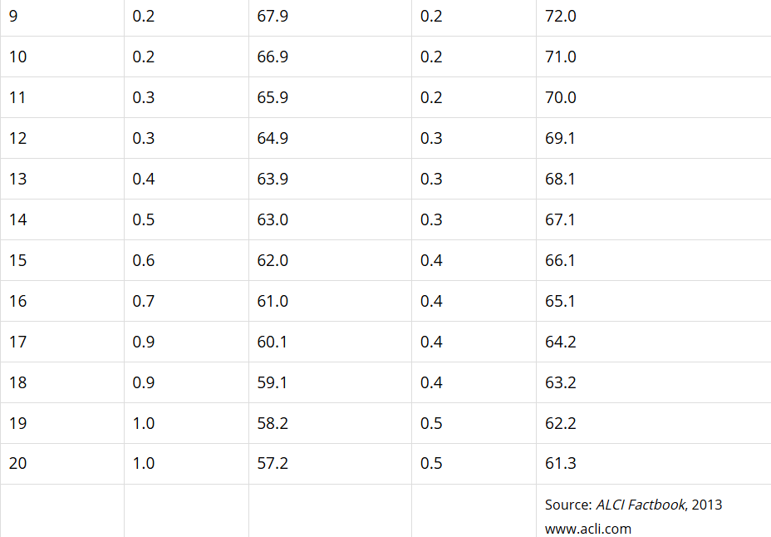
How Does it Work?
This mortality table shows that out of 96,535 of women alive at age 35, 97 will die before age 36.

That’s 0.001, or 1 per thousand.

Excerpt of Female Non-Smoker Mortality Table
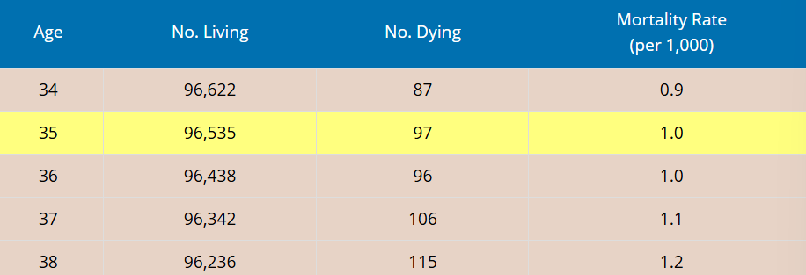
So if 1,000 women like Simone are insured for $100,000 each, Able Life can expect to pay $100,000 in death claims during the year. Able’s cost of benefits for this life insurance product would be $100.

$100,000 benefits paid ÷ 1,000 women = $100 premium per woman

Remember that the cost of benefits doesn’t include other company expenses or a reasonable profit for the company.

Mortality Tables

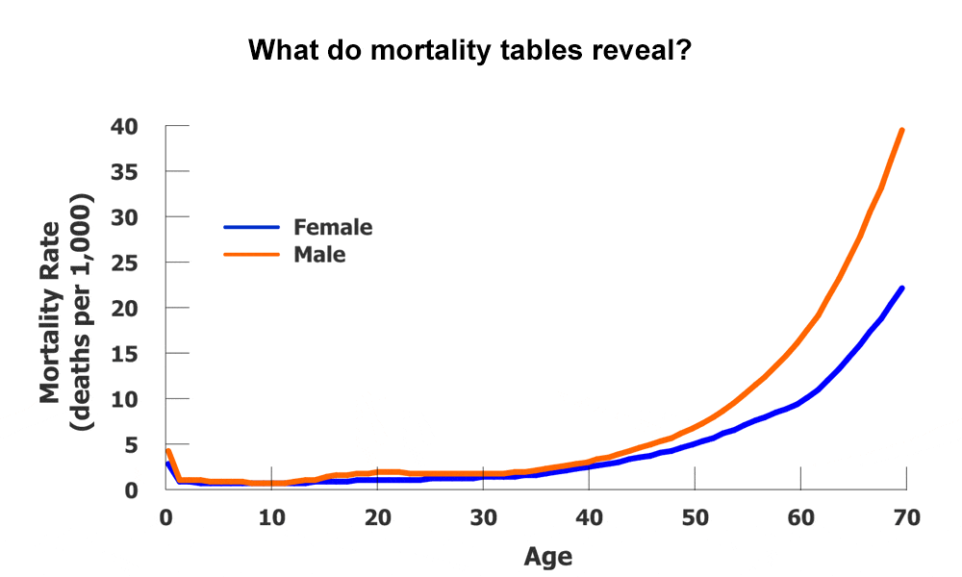
When not restricted by regulations, insurers can choose to price equivalent life insurance policies at a lower rate for women than for men of the same age.

What do you think?
In general, the higher the mortality rate for a group of insureds of the same age and sex, the [ higher / lower ] the cost of benefits and, as a result, the [ higher / lower ] the premium rate.
- Higher/higher
- Higher/lower
- Lower/higher
- Lower/lower
Answer: higher/higher
Explanation: For a group of insureds with the same risk class and the same age, the higher the mortality rate, the higher the cost of benefits and the higher the premium rate. Conversely, the lower the mortality rate, the lower the cost of benefits and premium rate.
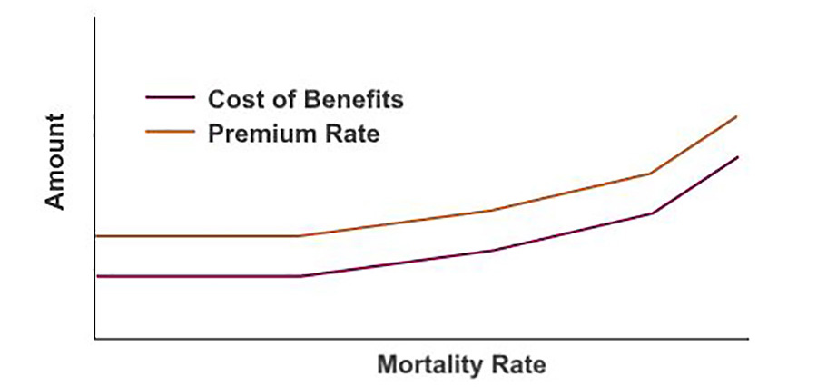Mortality rate, cost of benefits, and premium rate all move in the same direction.
As the mortality rate rises, so do the cost of benefits and the premium rate.

Costs of Lapses and Surrenders

Some policyowners decide they no longer want or need coverage.

If a policy doesn’t have a cash value, a policyowner may simply choose to stop paying premiums and allow the policy to lapse.

If a policy has accumulated a cash value, the policyowner will surrender the policy to the insurer in exchange for the policy’s cash surrender value.

To account for policy terminations and to calculate the cost of surrender benefits, insurers project lapse rates.

Blocks of Policies
Actuaries project the mortality rate and lapse rate for a given group of people expected to be insured under a product. This block of policies (nhóm các hợp đồng bảo hiểm - A group of policies issued to insureds who are all the same age, the same sex, and in the same risk classification) contains insureds who are all the same age, sex, and risk class.
Insurance companies decide which policies are included in a block of policies. For example, an insurer may classify all term life insurance policies issued to females age 35, who are nonsmokers and have no significant medical history, into one block of policies.

Let’s review
- For its new life insurance product, the Sequoia Insurance Company set an annual premium rate of $2.50 per $1,000 of coverage for 30-year-old females in the preferred risk class. Amanda Bird, who falls into this class, applied for a policy with a face amount of $100,000.

What will Amanda’s premium amount be for the year (not including miscellaneous charges)?
- $40
- $100
- $250
- $400

Answer: $250
Explanation: With a $100,000 face amount, Amanda’s policy has 100 coverage units ($100,000 ÷ $1,000). Because Amanda will pay $2.50 for each coverage unit, her annual premium amount is $250 (100 units × $2.50).

- Choose the term that you think provides the best answer.
Amanda can expect that the premium rate she pays for her coverage will be __________ the premium rate Sequoia charges other women who are her same age and in her same risk class.
- Greater than
- The same as
- Less than

Answer: the same as
Explanation: Insurers apply the same premium rate to everyone in the same block of policies. This block of policies is made up of insureds who are all the same age, the same sex, and in the same risk class.

- Choose the term that you think provides the best answer.
Sequoia’s actuaries projected that 10% of the people who are issued a policy will stop making premium payments before the end of Year 1, and before the insured person dies. This means that the_____________ rate for the first year is 10%.

- Lapse
- Mortality
Answer: Lapse
Explanation: The lapse rate represents the annual percentage of policies that don’t remain in force until the end of a given policy year because the policyowner stops paying premiums. The mortality rate reflects how many people in a group will die at each age.

Investment Earnings and Pricing Products

Learning Objective
Describe the effect of compound interest on investment earnings, and calculate the amount of interest earned on a given sum of money.
Describe how pricing factors affect profit levels.

Investment Earnings
Most policies are in force for years or decades before claims are payable. Insurers invest a portion of these premiums to generate investment earnings.
Why? The earnings from these investments provide additional funds that allow insurers to charge lower premium rates than they could if they relied on premium amounts alone.
How important are earnings? In 2013, 24 percent of all income insurers earned came from investment earnings.

What do you think?
When calculating premium rates, actuaries take into account the earnings the company’s investments will yield ( sinh lời. Consider the following situation:

Luau Insurance has two blocks of policies that are identical in every way except that the policies in Block A are likely to be in force for 10 years, whereas the Block B policies are likely to be in force for 25 years. All other factors being equal, how do you think projected investment earnings will affect premium rates for these two blocks?
- The premium rate for Block A will be higher than the premium rate for Block B
- The premium rate for Block B will be higher than the premium rate for Block A
- Block A and Block B will have identical premium rates
Answer: The premium rate for Block A will be higher than the premium rate for Block B
Explanation: Typically, the longer a block of policies is in force, the more investment earnings will affect the premium rate calculations. Luau can potentially invest the premiums from policies in Block B for a longer time, earning more interest, and resulting in lower premium rates.

How Investments Create Earnings
Many investments earn money in the form of interest payments. Interest is a payment for the use of money.
The rate of interest is expressed in terms of a percentage, such as 10 percent.
The principal (số tiền gốc) is the sum of money originally invested, loaned, or borrowed.

Simple Interest
Simple interest is interest on the original principal only.

Consider an example of a simple-interest loan. In such a transaction, the lender is considered to be the investor.
Example
Luther Odom loaned Peggy Sims $1,000 for one year at an annual interest rate of 10 percent. A 10 percent interest rate on a loan indicates that the borrower must pay the lender the amount originally borrowed, plus an additional 10 percent of that amount.

Analysis
At the end of one year, Peggy owed Luther $1,100: the $1,000 Luther loaned Peggy originally plus $100 interest ($1,000 x 0.10 = $100).

Compound Interest
Until a loan is repaid, the interest on a compound-interest loan continues to accrue—or accumulate. In this situation, the investor usually earns interest on both the principal and the accrued interest.

Calculating an interest amount on both the principal and the accrued interest is called compounding.

Interest on both the principal and the accrued interest is called compound interest.

Example
Marcia Woodson loaned Bernard Carter $1,000 at an annual interest rate of 10 percent. Bernard did not repay any of the principal or interest on the loan for two years.
Analysis
At the end of the first year, Bernard owed Marcia $1,100, calculated as
$1,000 principal + ($1,000 principal x 0.10) = $1,100
At the end of the second year, Bernard owed Marcia $110 in interest, calculated as
$1,100 principal and accrued interest x 0.10 = $110
Thus, at the end of the second year, Bernard owed Marcia a total of $1,210, calculated as
$1,100 + $110 = $1,210

The interest in our compound-interest example was compounded annually. However, interest can be compounded with any frequency—quarterly, monthly, or daily, for example.

Although the additional $10 earned by compounding interest in the example may seem small, over a long period of time, compounding interest has a dramatic effect on the total amount of interest that is earned.

Effect of Compounding
$1,000 held in an account for 25 years at 5% simple interest earns $1,250 simple interest.
$1,000 held in an account for 25 years at 5%, compounded annually, earns $2,386 compound interest.

Investment Earnings
For the sake of simplicity, we illustrated investment earnings in terms of an interest rate earned on a loan and on a bank account. However, insurance companies can receive investment earnings from many other types of investments.
For example, insurance companies invest money by buying stock in other companies. While an insurance company owns the stock, the company may collect dividend payments on that stock.
In addition, the insurer might be able to sell the stock for more than it paid.

Insurance Company Investments
Insurers can’t just invest premiums to earn the highest possible return.
Simone depends on Able Life to remain in business and to pay promised benefits. She doesn’t want Able to take crazy risks with her money.
Regulators make insurers invest in safe investments that provide stable earnings.
State laws require insurers to establish policy reserves (Liabilities that represent the amount an insurer estimates it needs to pay future benefits. ) to pay projected future policy benefits when they come due. Reserve requirements affect how an insurer manages its investments.

Operating Expenses

The premium amounts insurers charge must be adequate to pay for their expenses including:
- Taxes, licenses, and fees
- Salaries and commissions
- Costs associated with developing new products
- Costs associated with operating and maintaining the home office, regional offices, and/or sales offices
For some products, insurers account for operating expenses in the overall premium they charge for coverage.
Other products include separate charges to cover operating expenses.

Life Insurance Company Expenses
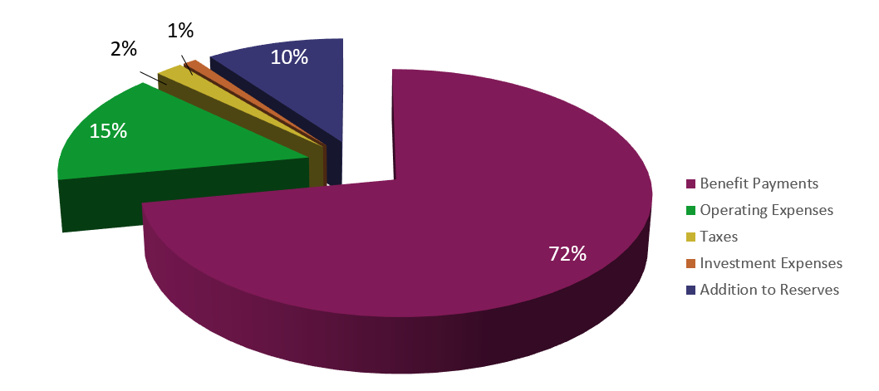
Image Description
This pie chart shows the percentage of insurer’s expenditures that went to pay benefits compared to operating and other expenses in 2017.

Including Profit in Pricing
So far we’ve covered actuaries’ first two pricing goals:
- Pay future benefits to customers
- Cover the cost of administering the products
The third goal is just as important if a company wishes to remain in business:
- Make a reasonable profit

Profit
Like all corporations, insurers attempt to generate a profit by producing goods and services and then selling them for more than what it costs to produce and deliver them.
Insurers have a responsibility to their owners and other stakeholders to operate profitably.
It’s imperative for actuaries to price products that make money because
- Any business that doesn’t make a profit won’t be around for long.
- The failure of an insurance company is terrible news for policyowners, beneficiaries, and the entire industry.
- Consistent profit improves an insurer’s financial strength and stability.

What do you think?

What conditions can improve the financial results for a product?

Consider each factor below that can impact the profit on a block of life insurance policies. Choose the factors that illustrate conditions that would tend to increase profit from the level the actuaries assumed when they priced the block of policies. (Choose all that apply.)
- Lower than anticipated mortality experience means fewer people die than are expected to, so the company pays less in death claims.
- Higher than anticipated investment earnings means the company earns more than expected through investments, leading to additional profit for the company.
- Lower than anticipated expenses means the company pays less to operate than it expected to.

Answer: All is correct
Explanatio:
Lower than anticipated mortality experience means fewer people die than are expected to, so the company pays less in death claims

Higher than anticipated investment earnings means the company earns more than expected through investments, leading to additional profit for the company

Lower than anticipated expenses means the company pays less to operate than it expected to

Pricing Products
See as this company actuary explains the role of actuaries in setting premium rates, profit margins, and those key elements, mortality, expenses, investment income.
Anthony Ferraro
Vice President and Actuary
New York Life

There are many elements to pricing a product and setting premium rates. For example, one, if they're building a life insurance product, you must understand how the mortality might develop over time. You have to understand the premiums that are paid. How we might invest those premiums. And another aspect that the actuaries get involved with are the expenses. So we have to cover our overhead expenses and we really have to also understand the variable expenses involved in pricing a product. So the key areas that the actuaries always turn to is in setting the premium rates, the profit margins, the target and those key elements, mortality, expenses, investment income. And then... even just as importantly, there is policyholder behavior. And this is where judgment may come in. When you sell a product, you don't know how people are really going to react so you need to make... have some assumptions about that. How many people will surrender their policies. How many people might take loans against the policies. And is the product designed appropriately to handle those contingent events.
The greater the company’s financial strength, the more stable the company’s future. The more stable the company’s future, the greater the chances that the company will be able to make good on its promises to customers.
Greater strength = Stable financial future

Risk Classes

Premium rates vary according to factors such as the insured’s age, gender, smoking habits, and risk class. Underwriters evaluate applications and assign each proposed insured to a risk class.
Remember risk classes?
- Standard—insureds who represent an average level of risk to the insurer
- Preferred—insureds who represent a below-average level of risk
- Substandard—insureds who represent an above-average level of risk
- Declined—proposed insureds who represent a risk that is too great for the insurer to cover

What do you think?
Assume Able Life’s actuaries set the annual premium rate for a given life insurance product at $4.50 per $1,000 of coverage, for a 35-year-old non-smoker female in the preferred risk class. Also assume that Simone, who is a 35-year-old, non-smoker female in the preferred risk class, applied for a policy from this product line with a $200,000 face amount.

Determine the annual premium amount Simone will have to pay according to this rate schedule.
- $450
- $900
- $1800
Answer: $900
Explanation:

Step 1: Calculate the number of coverage units for the policy.Simone’s policy has 200 coverage units ($200,000 face amount ÷ $1,000 per unit = 200 units).
Step 2: Multiply the price per coverage unit by the number of coverage units.Simone’s premium amount is $900 per year ($4.50 per unit × 200 units = $900).

